# 2.1 Matrix Operations

### Theorem 1

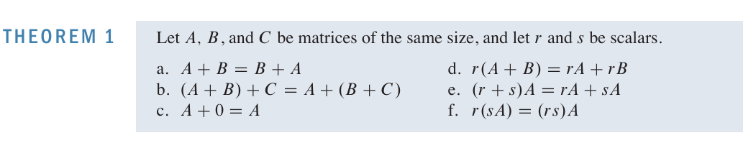

## Multiplication of matrices

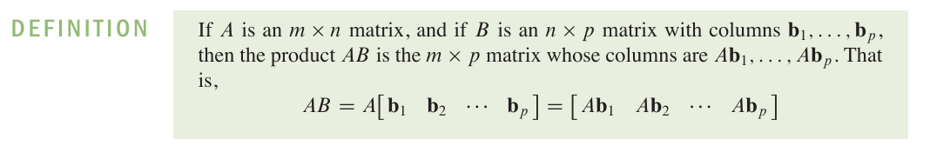

## Properties of Matrix Multiplication:

## Therorem 2

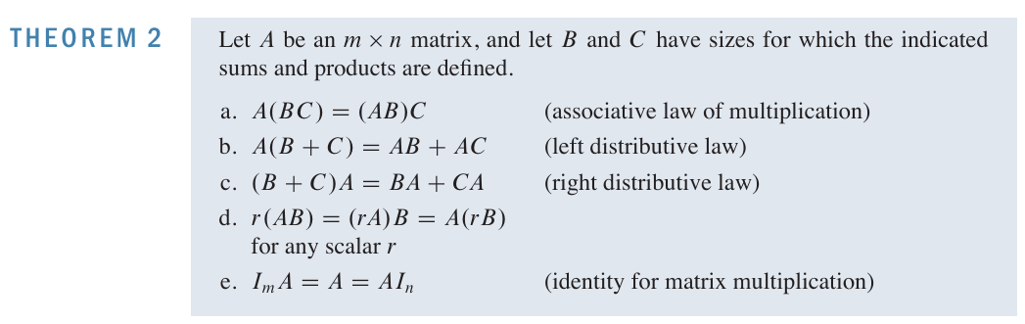

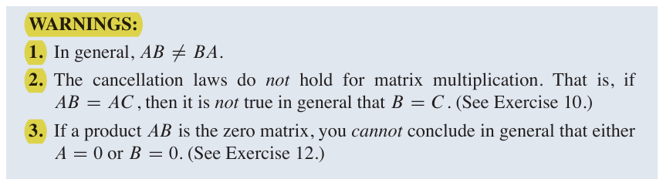

If *AB = BA*, we say that *A* and *B* **commute**.

## The transpose of a Matrix:

### Theorem 3

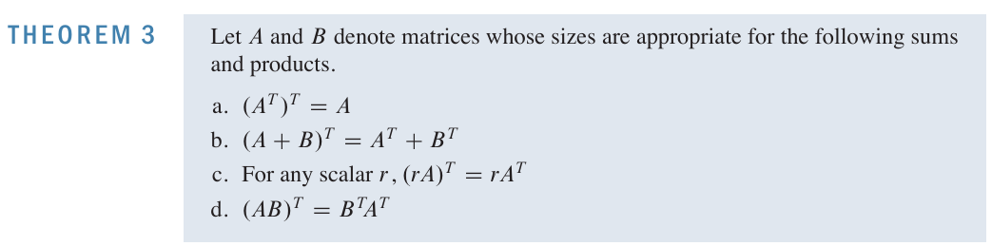

# 2.2 The inverse of a Matrix

An *n* x *n* matrix *A* is said to be **invertible** if there is an *n* x *n* matrix *C* such that

*CA* = *I*  and *AC = I*

The inverse is unique and is denoted by *A-1,* so that

*A-1A = I* and *AA-1 = I*

A matrix that is **not invertible** is sometimes called a **singular matrix**.

### Theorem 4

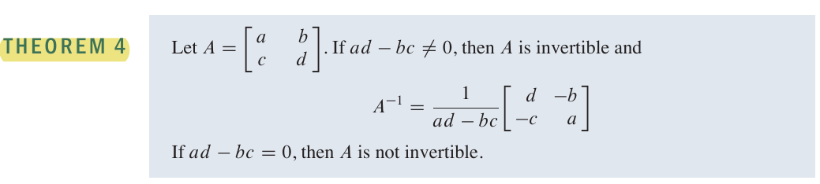Theorem 4 says that a 2 x 2 matrix *A* is invertible if and only if det *A* != 0.

### Theorem 5

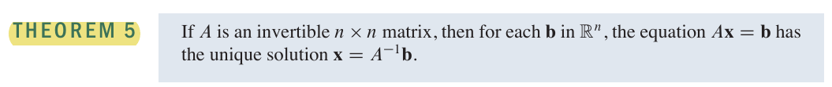

### Theorem 6

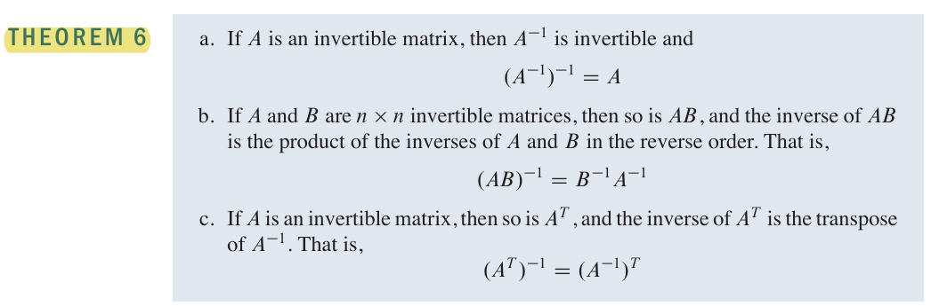

## Elementary Matrices

An elementary matrix is one that is obtained by performing a single elementary row operation on an identity matrix.

If an elementary row operation is performed on an *m* x *n* matrix *A*, the resulting matrix can be written as *EA*, where the *m* x *m* matrix *E* is created by performing the same row operation on Im.

Each elementary matrix *E* is invertible. The inverse of *E* is the elementary matrix of the same type that transforms *E* back into *I.*

### Theorem 7

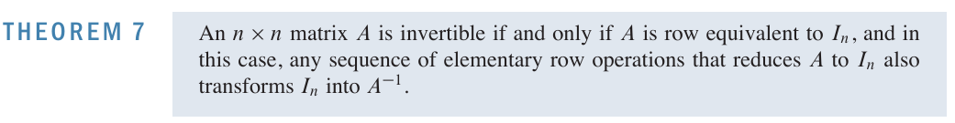

## 2.3 Characterizations of Invertible Matrices

### Theorem 8

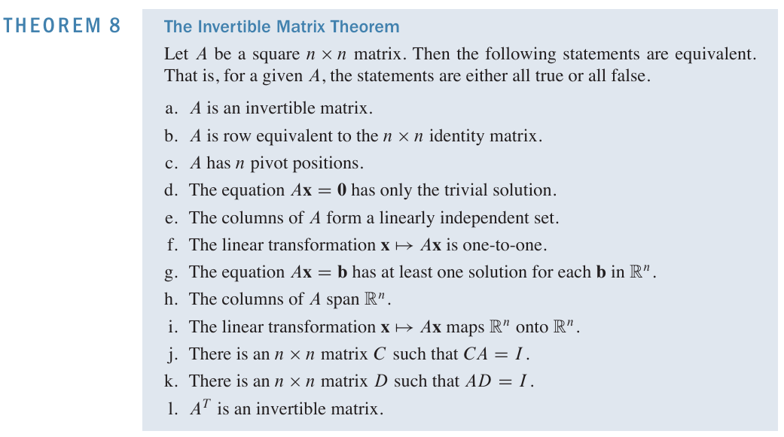The theorem above applies **only to square matrices.**

# 2.4 Partitioned Matrices

## Multiplication of Partitioned Matrices

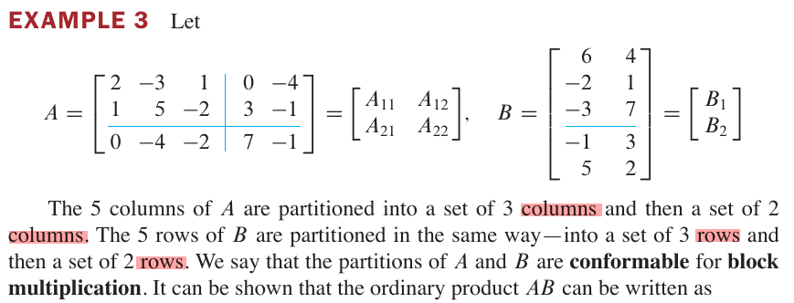

### Theorem 10

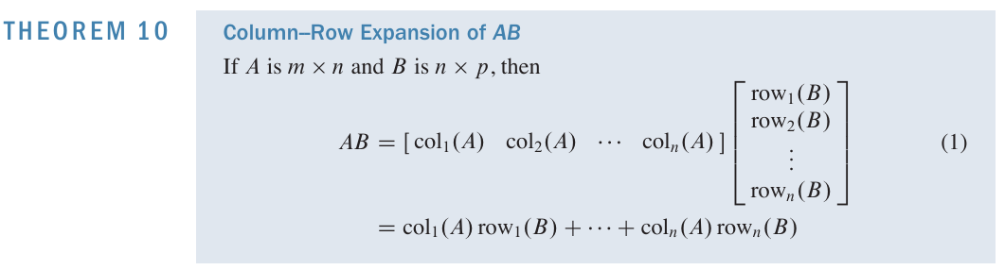

## Inverses of Partitioned Matrices

A **block diagonal matrix** is a partitioned matrix with zero blocks off the main diagonal (of blocks). Such a matrix is invertible if and only if each block on the diagonal is invertible.

# 2.5 Matrix Factorizations

## The LU Factorization

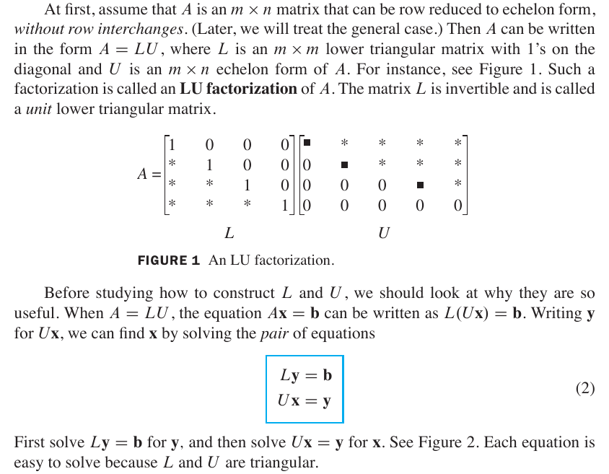

# 2.6 The Leontief Input-Output Model



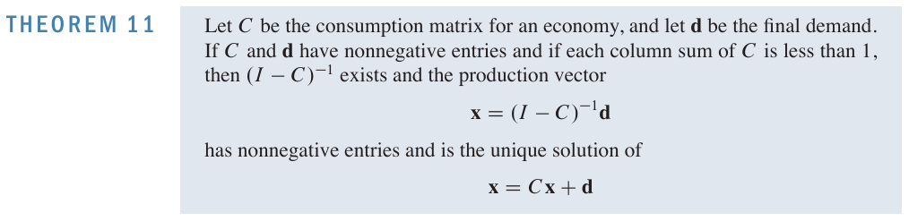

# 2.8 Subspaces of Rn

### **Subspace**:

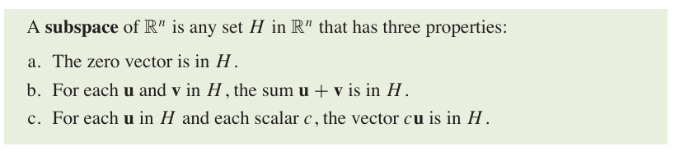

### Column Space:

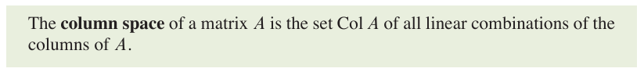

### Null Space

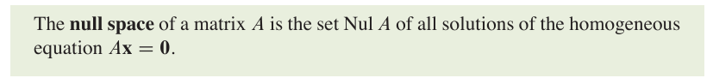

### Theorem 12

### Basis



### Theorem 13



# 2.9 Dimension and Rank

## Coordinate System

Definition

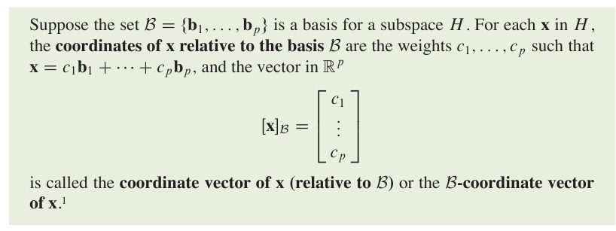

## The Dimension of a Subspace

Definition

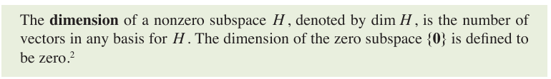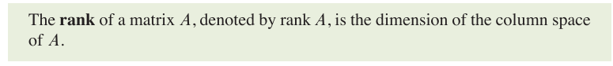The zero subspace has no basis, because the zero vector by itself forms a linearly dependent set

### Theorem 14 – The Rank Theorem



### Theorem 15 - The Basis Theorem

### The Invertible Matrix Theorem continued

